**HOE 5 ER Diagram Assignment by Joshua Troup**

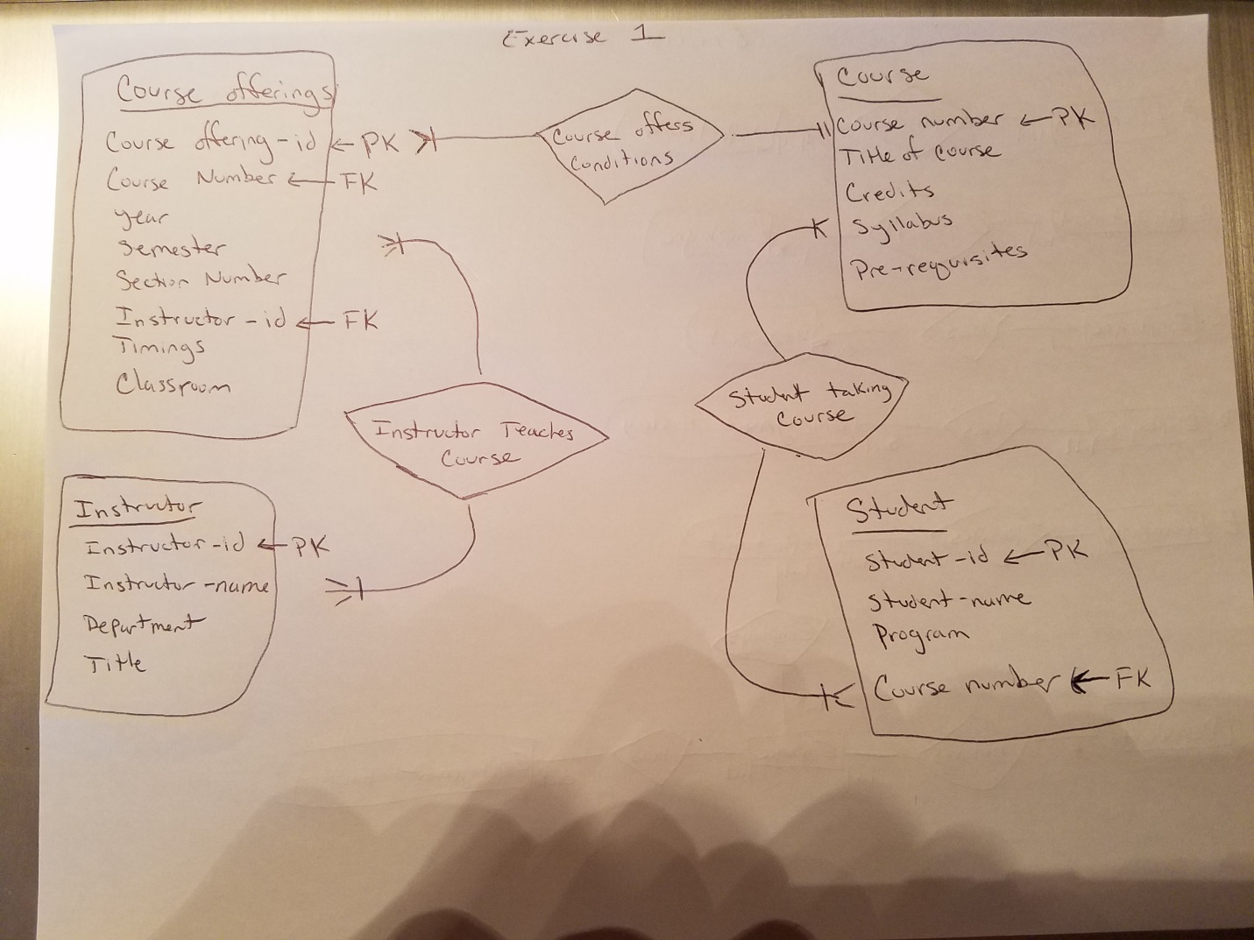

**Clarion University Database Tables:**

**Course (Course number, Title of course, Credits, Syllabus, Prerequisites)**

**Course offerings (Course offerings-id, Course number, Year, Semester, Section number, Instructor-id, Timings, Classroom)**

**Student (Student-id, Student-name, Program, Course number)**

**Instructor (Instructor-id, Instructor-name, Department, Title)**

**EXERCISE #1**

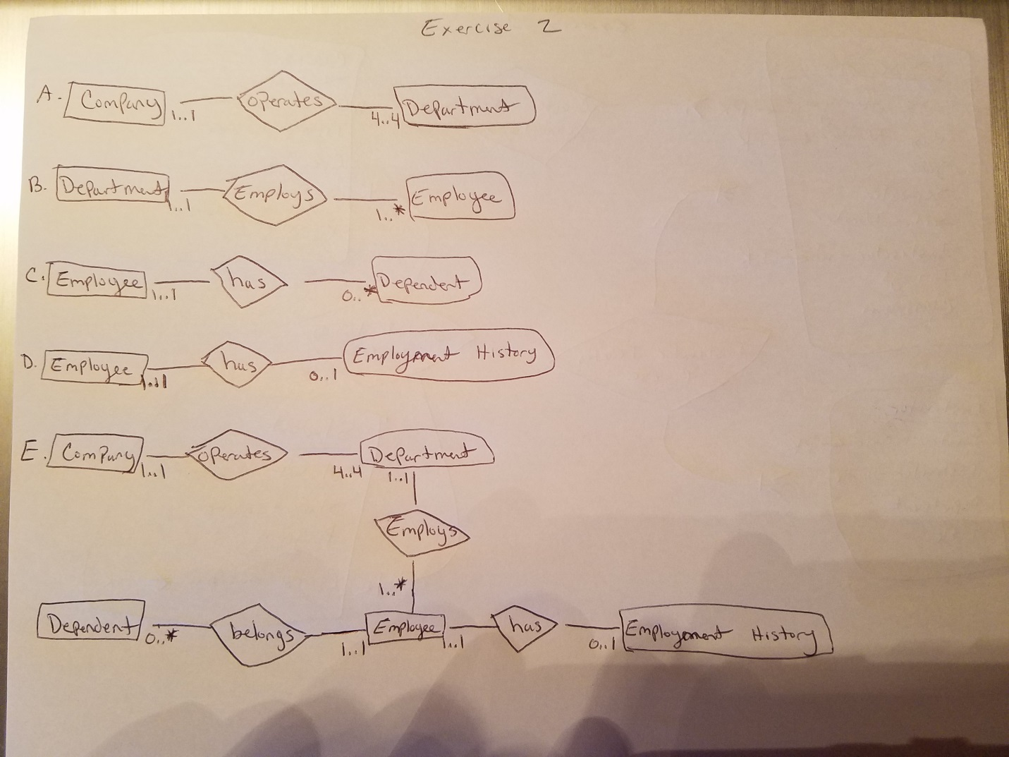

**EXERCISE #2**

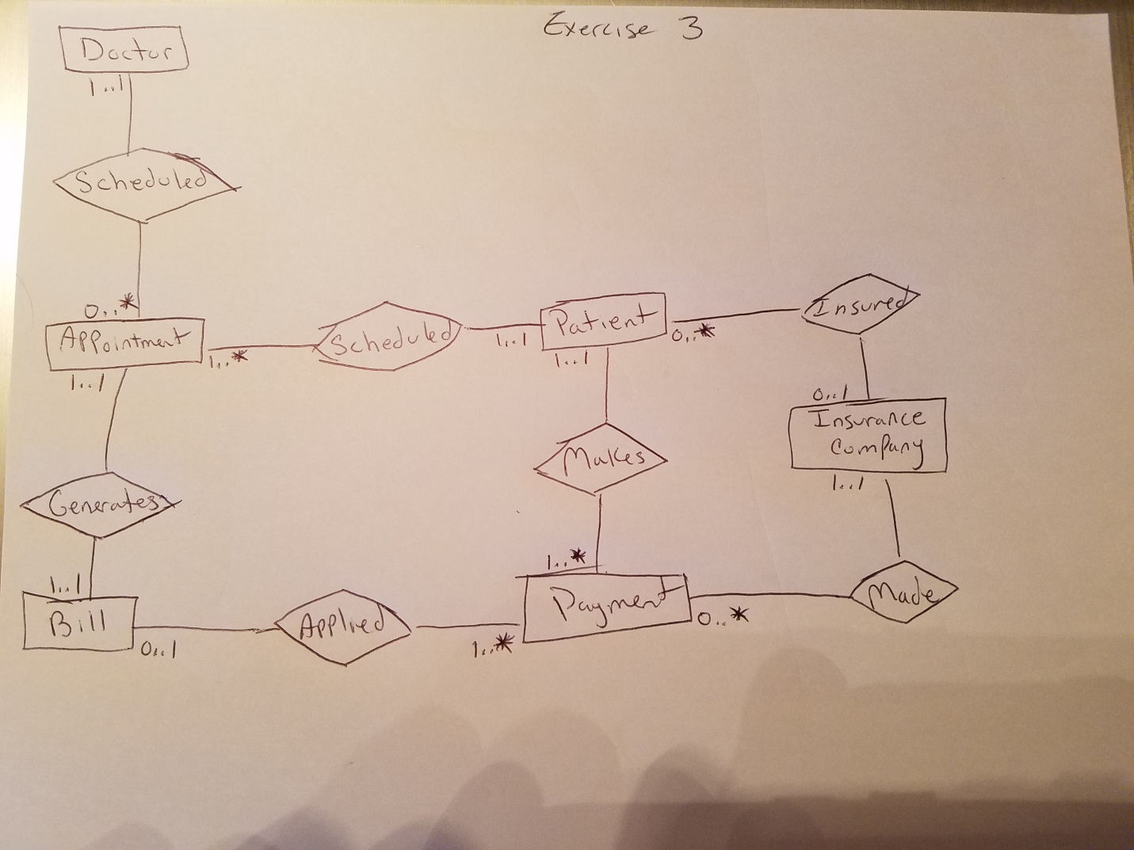

**EXERCISE #3**